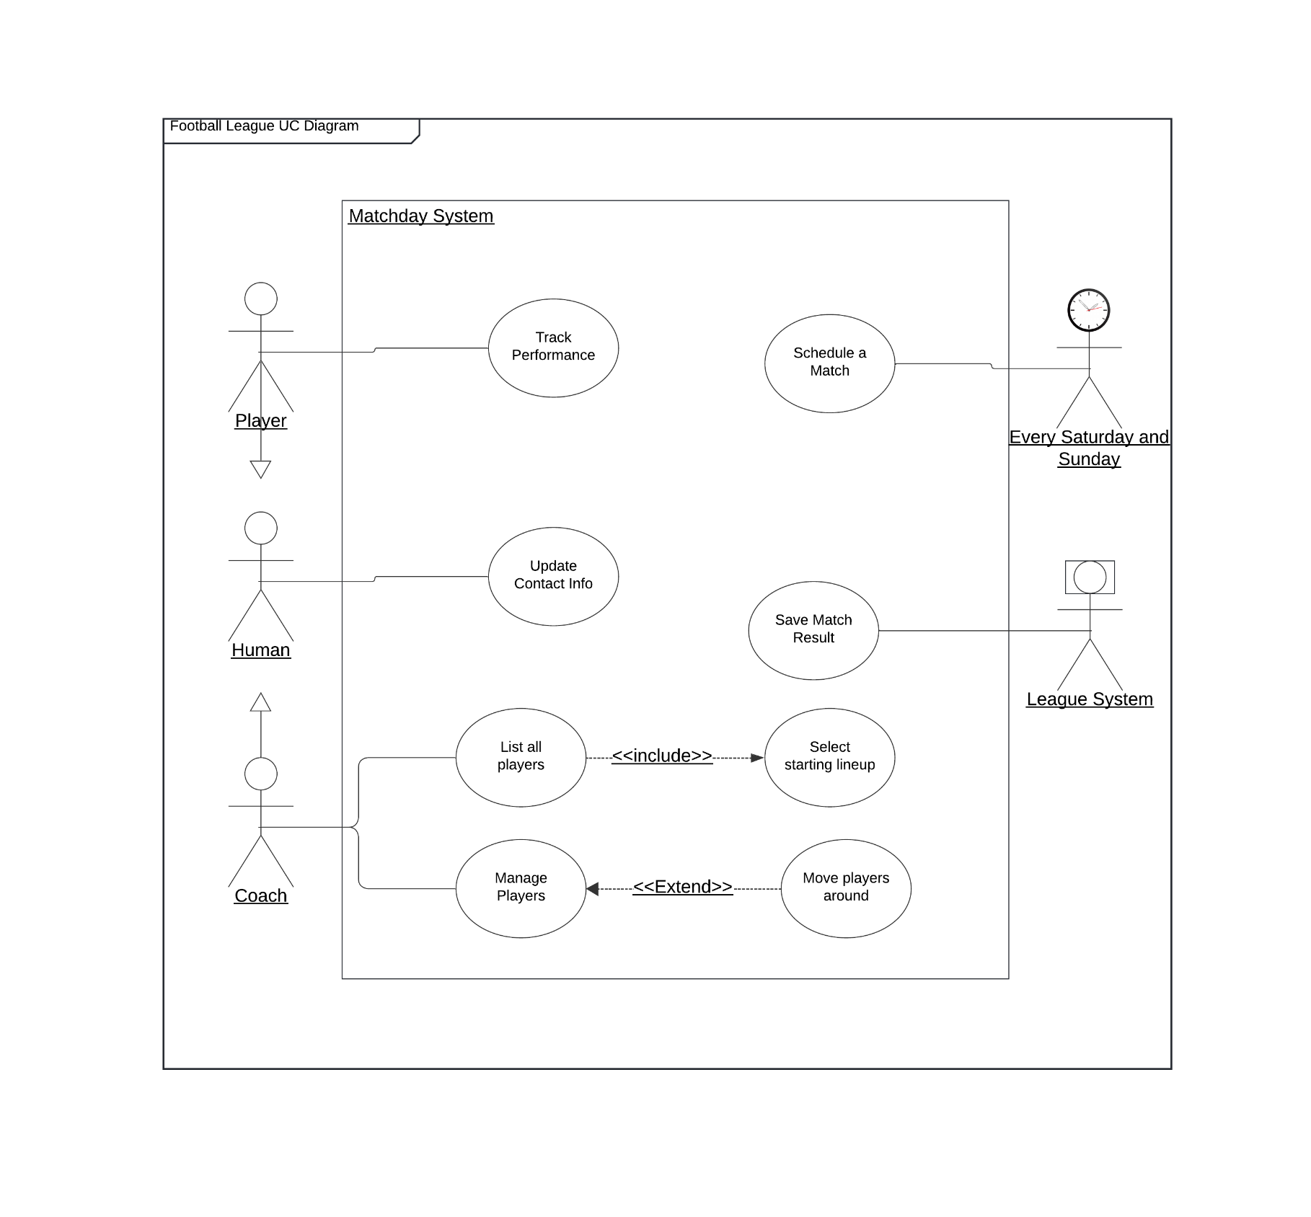
Use Case Diagram

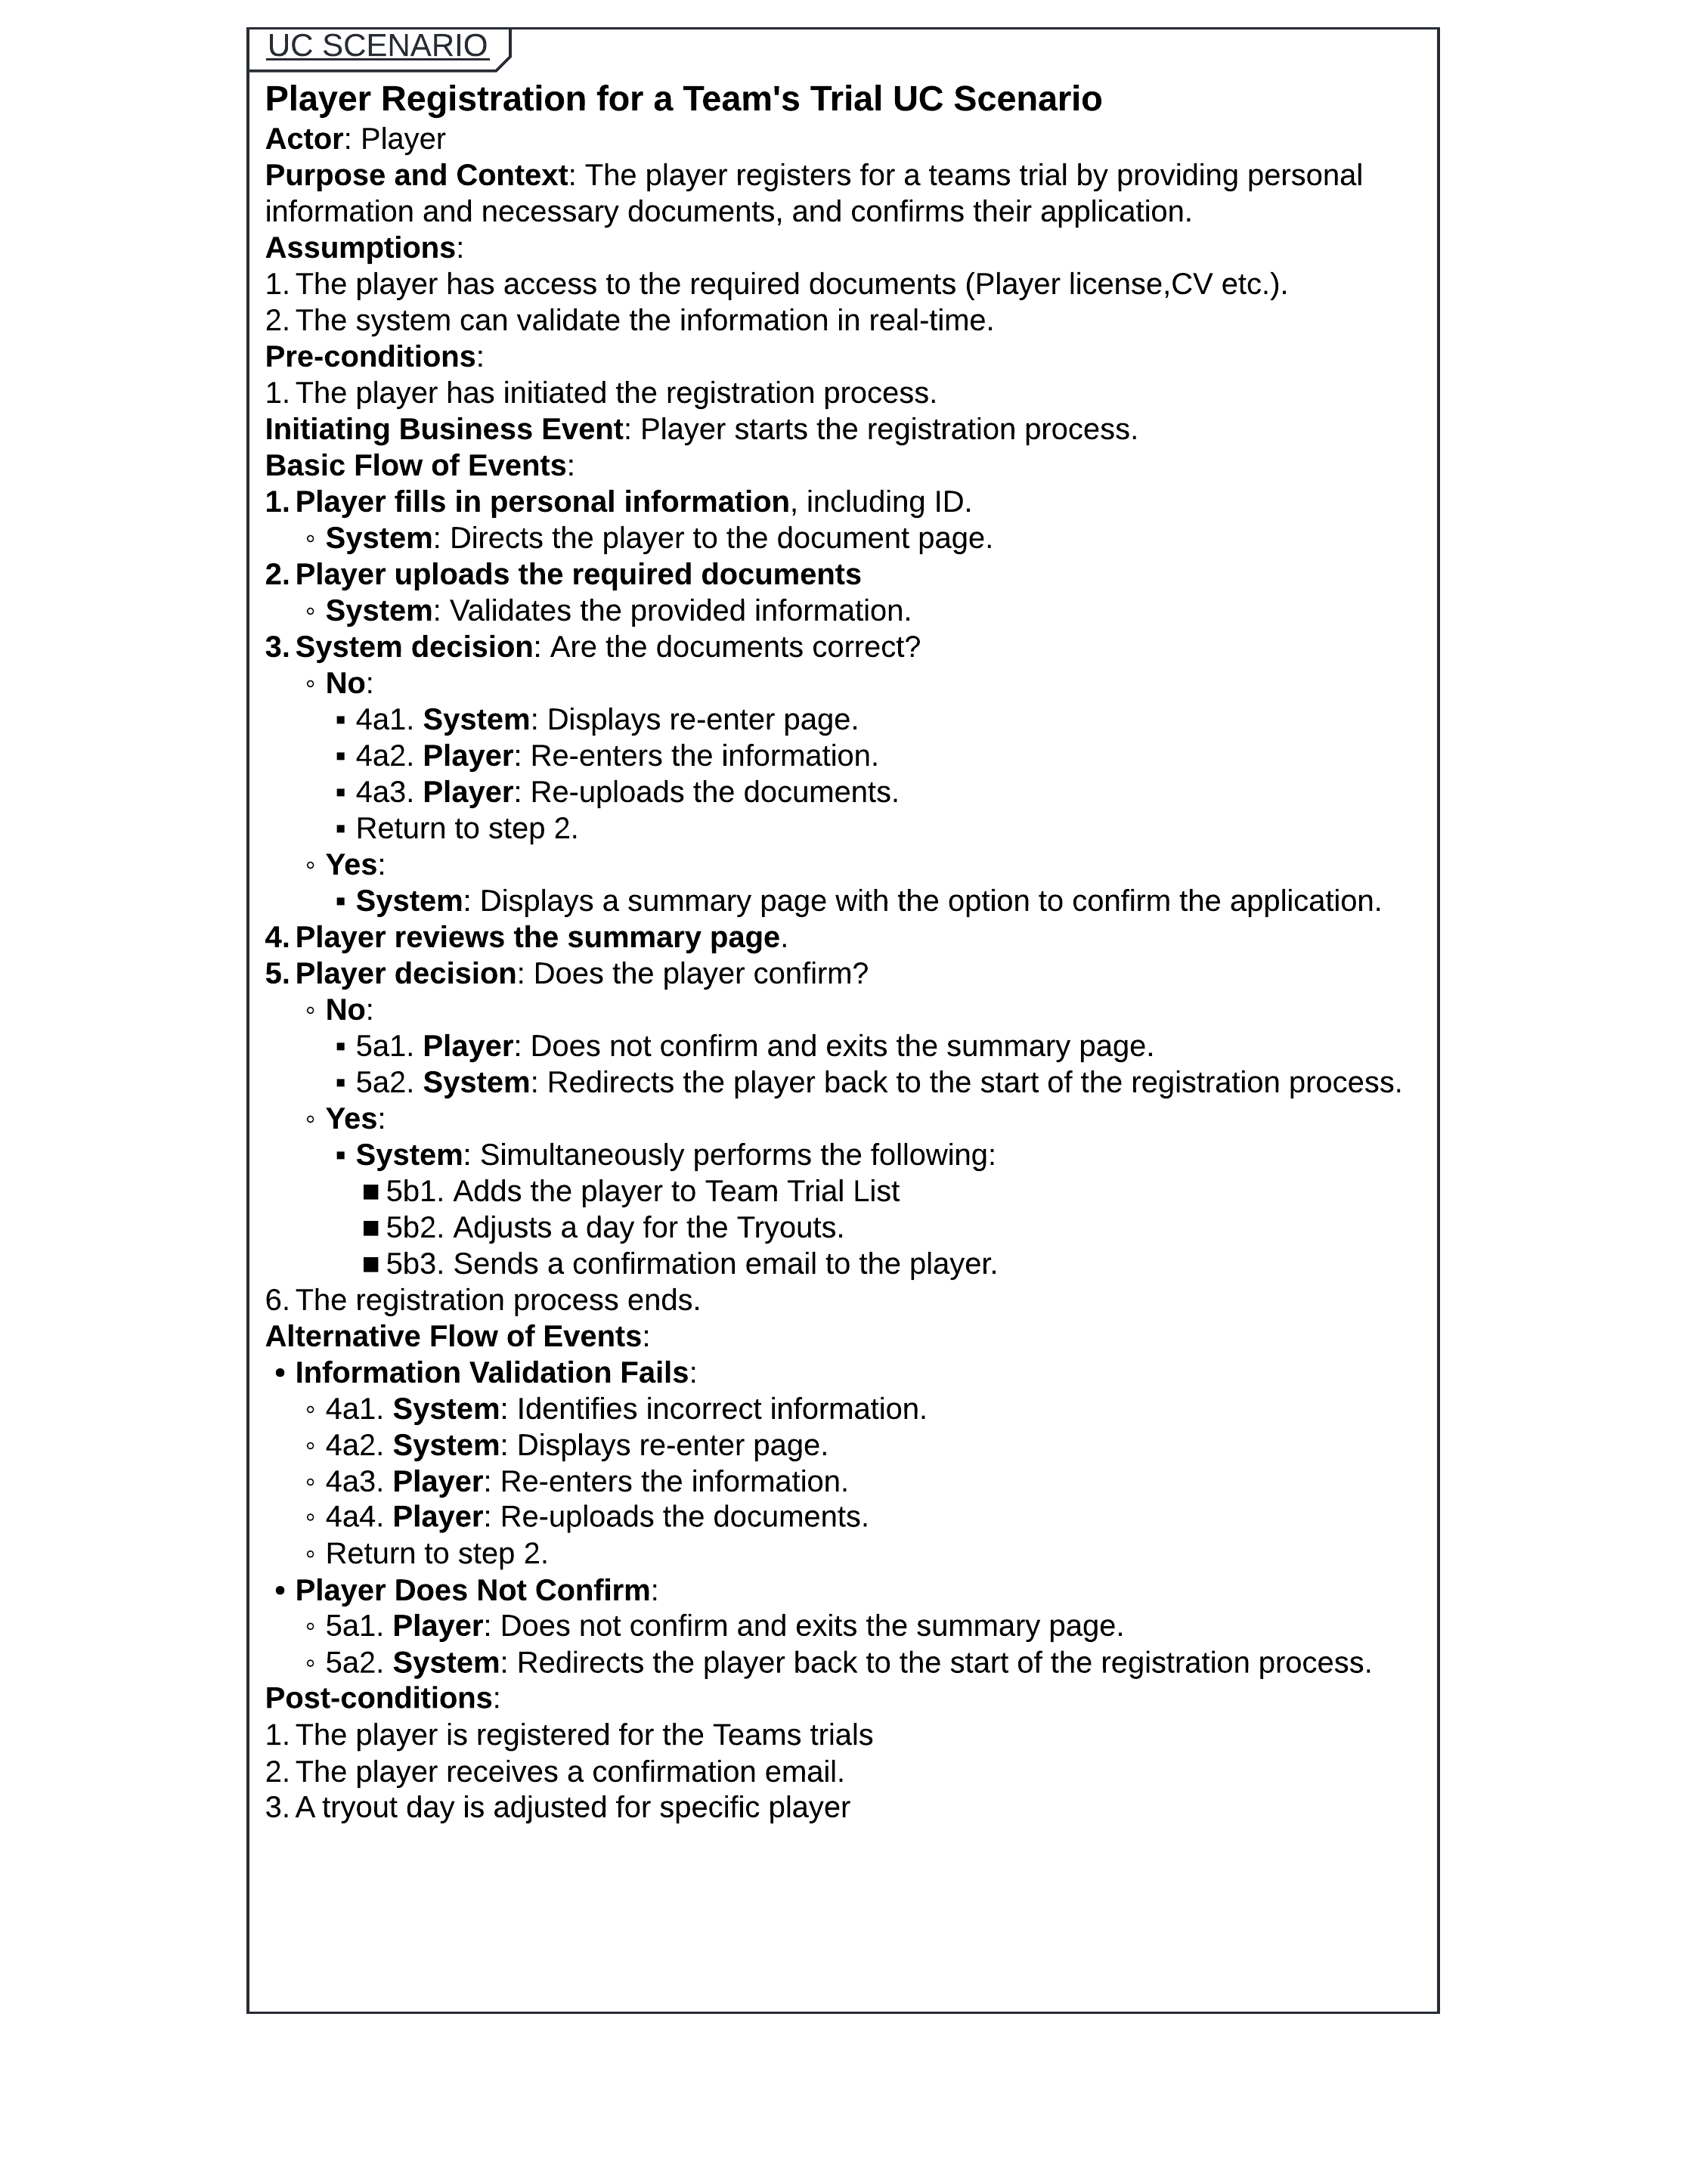
Use Case Scenario “Player Registration”

Activity Diagram “Player Registration”
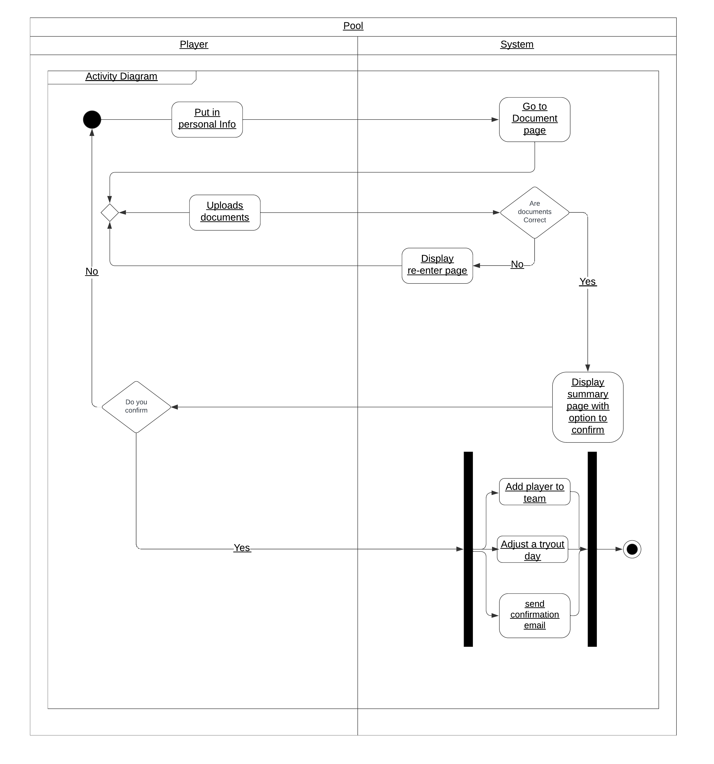
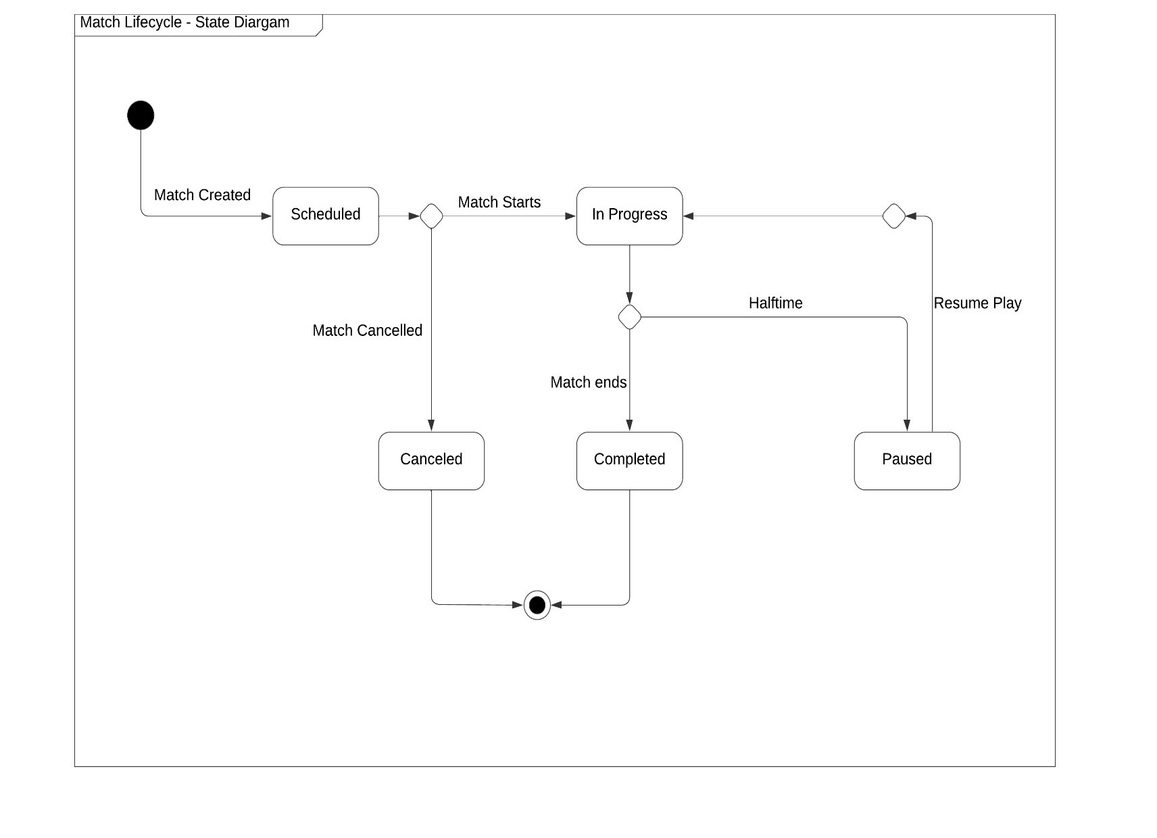
State Diagram “Match Lifecycle”
Ss
S
S
S
S
S
S
S

State Diagram - Design Description
The state diagram describes the lifecycle of a Match object. When a Match is created, it starts with the status of Scheduled. Based on specific events or triggers, the Match object transitions between the following states:
Scheduled : The Match is planned and ready to start. This is the initial state when a Match is created.
Trigger: Match Starts transitions the Match to the In Progress state.
In Progress: The Match is actively being played.
Trigger: Halftime causes the Match to transition to the Paused state.
Trigger: "Match Ends" transitions the Match to the Completed state.
Paused : The Match goes to half time and stops for 15-20 minutes.
Trigger: "Resume Play" moves the Match back to the In Progress state.
Completed : The Match has concluded, and the results are finalized. This is one of the two possible end states for the Match.
Canceled : If the Match is called off before it starts, it transitions directly from the Scheduled state to Canceled. This is the other possible end state for the Match.
The Match object lifecycle can only end in one of two ways:
Completed: The Match is played and finished successfully.
Canceled: The Match is called off and removed from the active schedule.
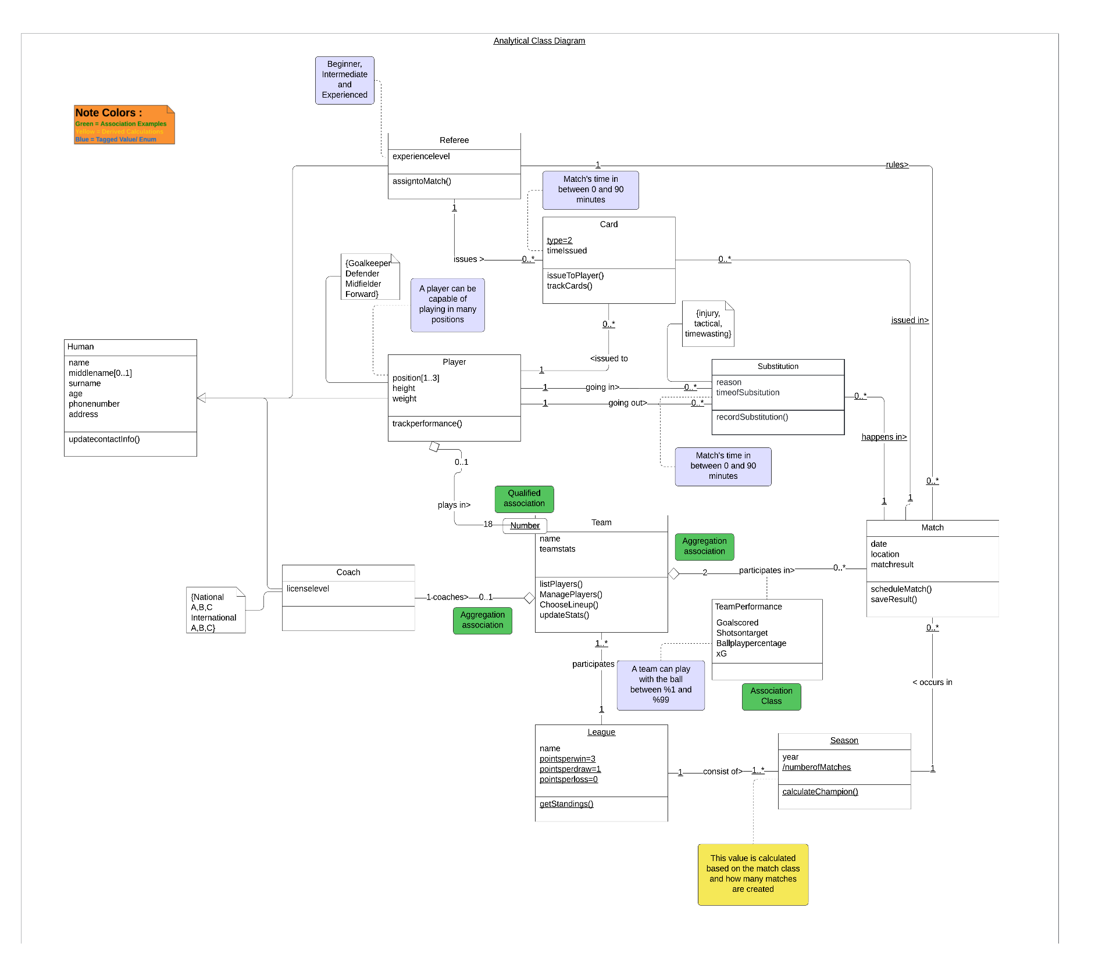
Class Diagram – Analytical

The above analytical class diagram shows the structure of the
Football League System
including key parts like players, coaches, teams, matches, leagues, referees, and substitutions. The system is designed to organize and manage football matches by tracking players, team performance, and match results.
The Human class is the base class and contains shared details such as name, surname, and address. It is inherited by Player and Coach. Players are part of teams, and each team is led by a coach. Teams participate in leagues and play matches. The Match class connects teams, referees, and substutions, while tracking important details such as date, location, and matchResult.
Relationships between classes are shown using aggregation (for example, teams contain players) and composition (for example, matches include substitutions and team performance). Multiplicities are used to show how many objects are involved, such as a team having up to 18 players.
Some special features of the system include:
- Multi-value Attributes: A player can have multiple positions
- Derived Attributes: Number of matches in a season can be calculated depending on Match Class
- Qualified Associations: A player can be identified from the number he waers.
The diagram also includes notes and tagged values to explain more complex parts, such as match rules and substitution reasons. It also uses a parent class like Human to group shared features.
This is an analytical class diagram, meaning it focuses on the overall design of the system rather than specific programming details like data types or implementation logic.
In the next step, this diagram will be turned into a design class diagram, which will include specific details like data types, database connections, and methods. For now, this diagram provides a clear and high-level view of the system’s structure and relationships.

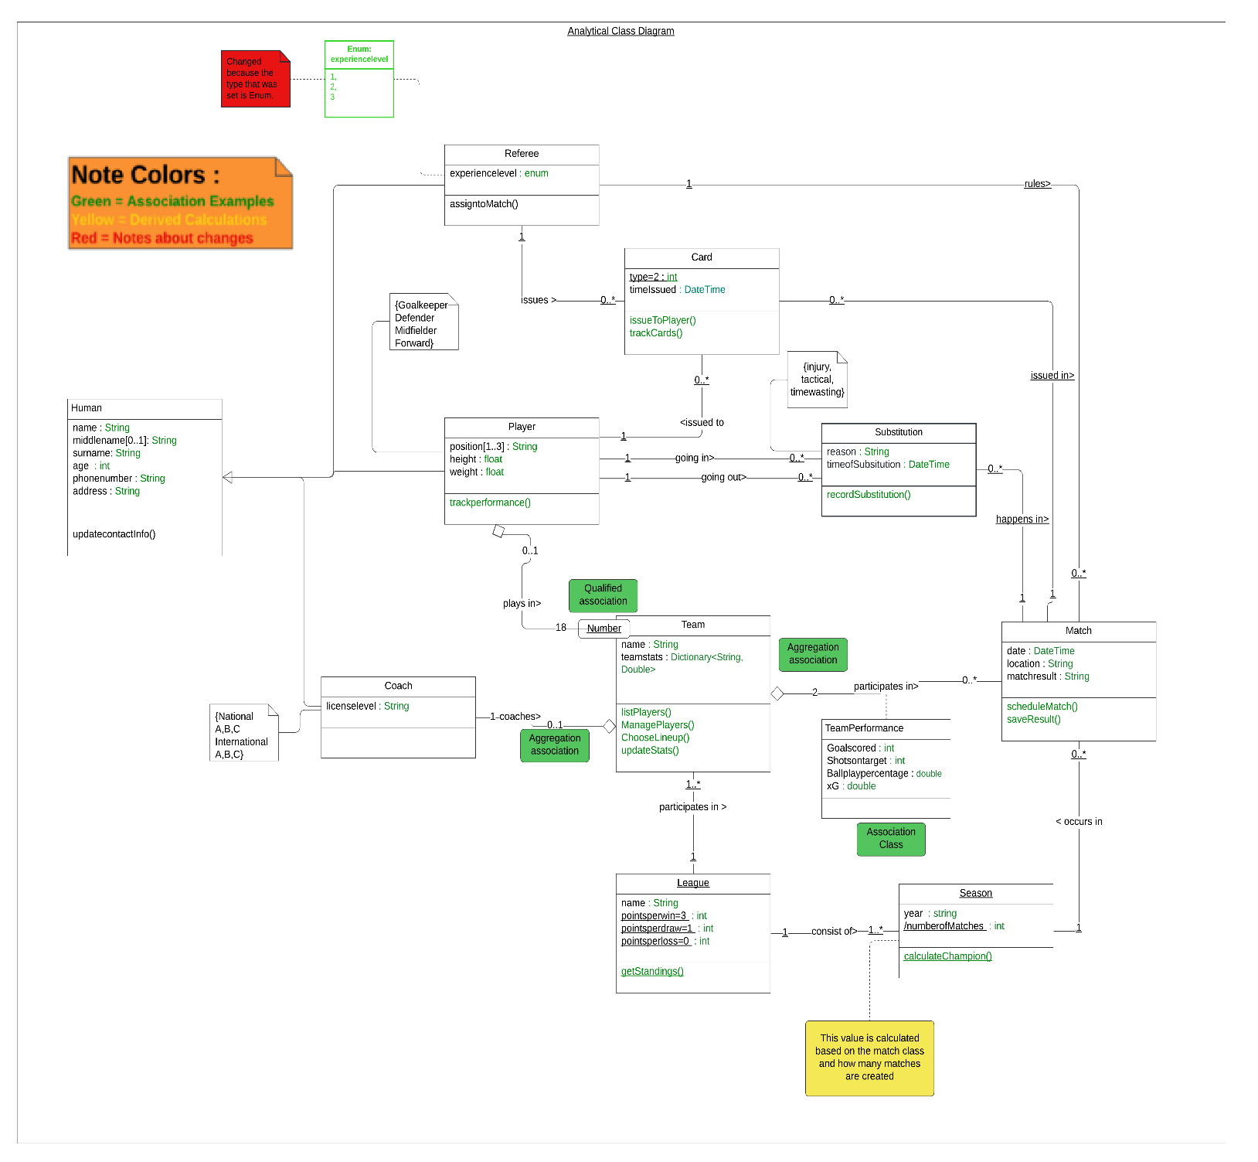
Class Diagram – Design

